Lab Exercise 8: Using the Set Operators

1. Produce a report to display all the employees that have change their job in the company during their service.

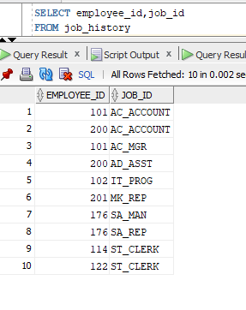

1. Retrieve the employees that have work as AD_ASST before and now having the same designation again.

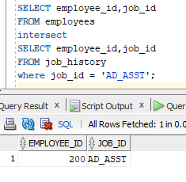

1. By using set operator, find the countries that don’t have any department located in them. Display the country number and name.

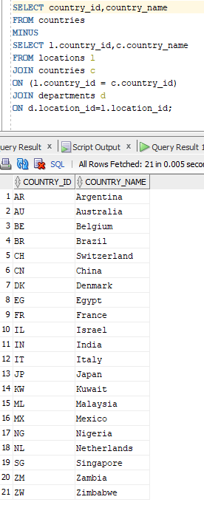

1. Produce a report on list of jobs in department 60 and 90 by using the set operator. Display the department ID and job ID only.

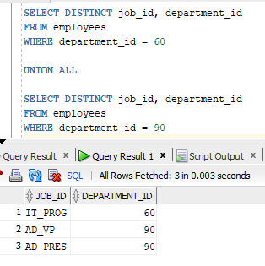

1. Produce a report for the following specifications.
   * Location ID and department name for all the departments regardless whether or not they belong to any city.
   * Location ID and city name regardless of whether or not they have department name.

